## Subtask 1

Place your one Kali VM and one XP VM on the same virtual network. Perform an XMAS scan on the XP machine, while capturing the packets between them. You should submit the following.

1. A short explanation of the differences you see in the XMAS scan against the Windows machine versus against what happened when scanning the Kali machine. Reference your packet capture in the explanation.

In this task I have preformed an XMAS scan against both a Windows XP and Kali Linux machine, for simplicity I narrowed the scope down to port 21 on both machines to make analysing the data easier. With the kali machine in its default state and the windows machine with its firewall off both scans showed similar results with port 21 being closed and Wireshark shows a [RST,ACK] packet being returned.

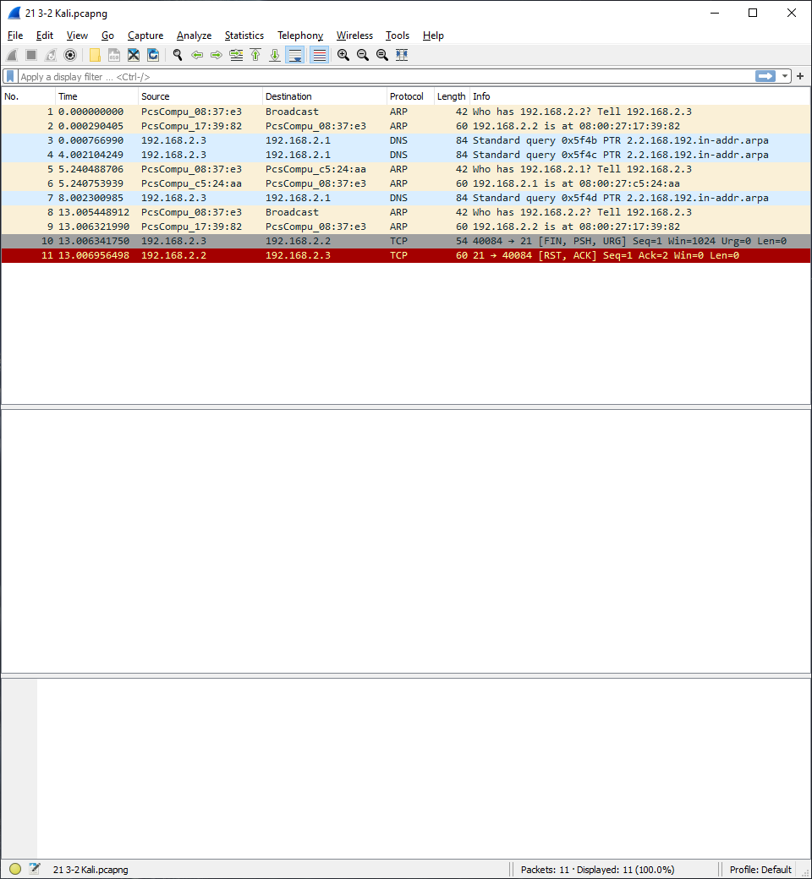

Kali Scan

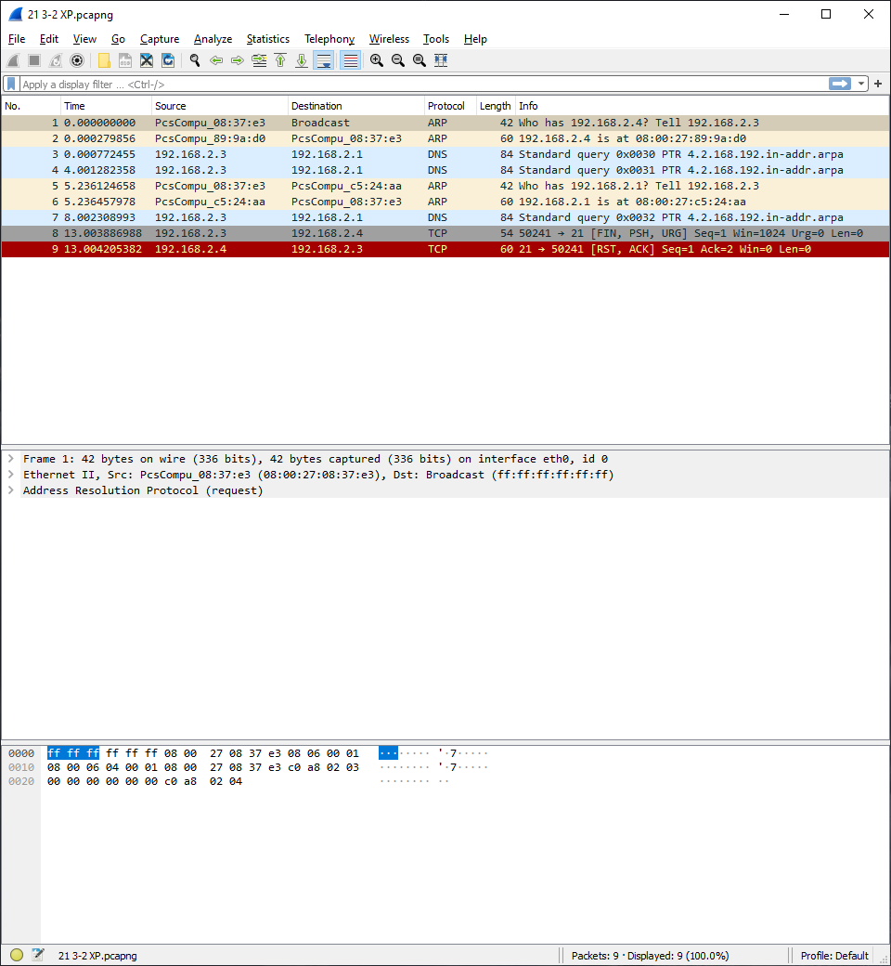

Windows XP Scan (Firewall OFF)

However, if I turn the windows firewall on like it would normally be the scan shows the port is in an “Open | Filtered” state along with Wireshark showing no packets being returned.

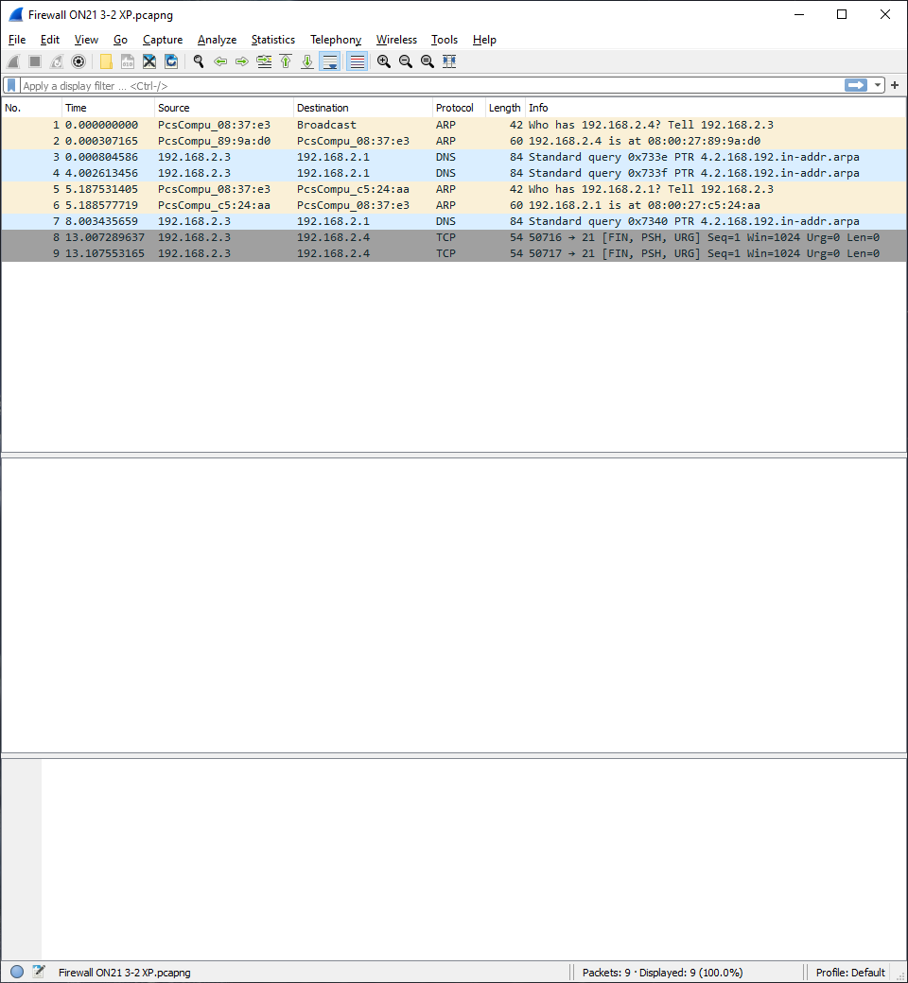

Windows XP Scan (Firewall ON)